Air Pollution Analysis by Detecting Oxygen Level using Mobile Application

Main page

**Acknowledgement**

With a great pleasure, we present this report on ***"Indoor* Oxygen Checking using Smart Phone "**which has been accomplished as part of the dissertation of MCA-V curriculum. First of all, we would like to thank **Gujarat University** for giving us such a good opportunity to really learn something new. We have given our best to grab this dissertation as learning opportunity and explore the area of it as much as we could.

We are highly grateful to our subject guide **Miss Jigna Satani** for giving us the opportunity of working under her genuine guidance. She has shared her valuable knowledge in each and every step for this ambitious work throughout. Her patience, motivation, enthusiasm and immense knowledge are the reasons behind the completion of this dissertation.

We would like to thank all the respected faculty members of our department for providing us valuable feedbacks during the presentations which shaped the dissertation to its final form.

Finally, we would like to thank our parents, family members and friends for their constant motivation, care and support because of which we are able to complete our dissertation successfully.

**-DHRUVIKA CHAUHAN**

Index

Introduction

Abstract

1. Pollution

1.1 What is pollution?

1.2 What is Air pollution?

1.3 Causes of Air Pollution

1.4 Effects of Air Pollution

1.5 Solution of Air pollution

2. Smart Phone

2.1 What is Smart Phone?

2.2 Which kind of Smart Phone required?

3. Andriod Studio

3.1 What is Android Studio?

3.2 Version of Android Studio

3.3 How it will work?

4. Micro Controller

4.1 What is Micro Controller?

4.2 Types of Micro Controller

4.3 Uses of Micro Controller

4.4 How it will work?

5. USB Cable

5.1 What is USB Cable?

5.2 Works of USB Cable

6.Sensor

6.1 What is Sensor?

6.2 Type of Sensor

6.3 Uses of Sensor

7. How these Application works?

Conclusion

References

Introduction

1. Pollution

1.1 What is Pollution?

**Pollution**, also called **environmental pollution**, the addition of any substance(solid, liquid, or gas) or any form of energy (such as heat, sound, or radioactivity) to the environment at a rate faster than it can be dispersed, diluted, decomposed, recycled, or stored in some harmless form. The major kinds of pollution, usually classified by environment, are air pollution, water pollution, and land pollution. Modern society is also concerned about specific types of pollutants, such as noise pollution, light pollution, and plastic pollution. Pollution of all kinds can have negative effects on the environment and wildlife and often impacts human health and well-being.Pollution is the introduction of contaminants into the natural environment that cause adverse change. Pollution can take the form of chemical substances or energy, such as noise, heat or light. Pollutants, the components of pollution, can be either foreign substances/ energies of natural occurring contaminants.

1.2 What is Air Pollution?

Airpollution occurs when harmful or excessive quantities of substances including gases, particulates, and biological molecules are introduced into Earth's atmosphere. It may cause diseases, allergies and even death to humans; it may also cause harm to other living organisms such as animals and food crops, and may damage the natural or built environment. Both human activity and natural processes can generate air pollution. An air pollutant is a material in the air that can have adverse effects on humans and the ecosystem. The substance can be solid particles, liquid droplets, or gases. A pollutant can be of natural origin or man-made. Pollutants are classified as primary or secondary. Primary pollutants are usually produced by processes such as ash from a volcanic eruption. Other examples include carbon monoxide gas from motor vehicle exhausts or sulphur dioxide released from the factories. Secondary pollutants are not emitted directly. Rather, they form in the air when primary pollutants react or interact. Ground level ozone is a prominent example of secondary pollutants. Some pollutants may be both primary and secondary: they are both emitted directly and formed from other primary pollutants.Any visible or invisible particle or gas found in the air that is not part of the original, normal composition.Air Pollution occurs when harmful or excessive quantities of substances including gases, particulates, and biological molecules are introduced into Earth’s atmosphere. Indoor air pollution and poor urban air quality are listed as two of the world’s worst toxic pollution problems. Both human activity and natural processes can generate air pollution.

* 1. Effects of Air Pollution

1.Acidification:  
Chemical reactions involving air pollutants can create acidic compounds which can cause harm to vegetation and buildings. Sometimes, when an air pollutant, such as sulfuric acid combines with the water droplets that make up clouds, the water droplets become acidic, forming acid rain. When acid rain falls over an area, it can kill trees and harm animals, fish, and other wildlife.   
2. Eutrophication:  
Rain can carry and deposit the Nitrogen in some pollutants on rivers and soils. This will adversely affect the nutrients in the soil and water bodies. This can result in algae growth in lakes and water bodies, and make conditions for other living organisms harmful.

3. Ground-level ozone:  
Chemical reactions involving air pollutants create a poisonous gas ozone (O3). Gas Ozone can affect people’s health and can damage vegetation types and some animal life too.

4. Particulate matter:  
Air pollutants can be in the form of particulate matter which can be very harmful to our health. The level of effect usually depends on the length of time of exposure, as well the kind and concentration of chemicals and particles exposed to.

Short-term effects:

It  include irritation to the eyes, nose and throat, and upper respiratory infections such as bronchitis and pneumonia. Others include headaches, nausea, and allergic reactions. Short-term air pollution can aggravate the medical conditions of individuals with asthma and emphysema.

Long-term health effects:

It can include chronic respiratory disease, [lung cancer](http://www.eschooltoday.com/cancer/causes-of-cancer.html), heart disease, and even damage to the brain, nerves, liver, or kidneys. Continual exposure to air pollution affects the lungs of growing children and may aggravate or complicate medical conditions in the elderly.

1.4 Cause of Air Pollution

1.Emissions from industries and manufacturing activities:

Consider a typical manufacturing plant: You will notice that there are long tubes (called chimneys) erected high into the air, with lots of smoke and fumes coming out of it. Waste incinerators, manufacturing industries and power plants emit high levels of carbon monoxide, organic compounds, and chemicals into the air. This happens almost everywhere that people live. Petroleum refineries also release lots of hydrocarbons into the air..

2. Burning Fossil Fuels:  
After the industrial age, transportation has become a key part of our lives. Cars and heavy-duty trucks, trains, shipping vessels and airplanes all burn lots of fossil fuels to work. Emissions from automobile engines contain both primary and secondary pollutants. This is a major cause of pollution and one that is very difficult to manage. This is because humans rely heavily on vehicles and engines for transporting people, good and services.  
  
Fumes from car exhausts contain dangerous gases such as carbon monoxide, oxides of nitrogen, hydrocarbons and particulates. On their own, they cause great harm to people who breathe them. Additionally, they react with environmental gases to create further toxic gases. [Click here to see the effects](http://eschooltoday.com/pollution/air-pollution/effects-of-air-pollution.html)

3. Household and Farming Chemicals:  
Crop dusting, fumigating homes, household cleaning products or painting supplies, over the counter insect/pest killers, fertilizer dust emits harmful chemicals into the air and cause pollution. In many cases, when we use these chemicals at home or offices with no or little ventilation, we may fall ill if we breathe them.

1.5 Solution of Air Pollution

Renewable fuel and clean energy production :

The most basic solution for air pollution is to move away from fossil fuels, replacing them with alternative energies like solar, wind and geothermal.

Energy conservation and efficiency :

Producing clean energy is crucial. But equally important is to reduce our consumption of energy by adopting responsible habits and using more efficient devices.

Eco-friendly transportation :

Shifting to electric vehicles and hydrogen vehicles, and promoting shared mobility (i.e carpooling, and public transports) could reduce air pollution.

Green building :

From planning to demolition, green building aims to create environmentally responsible and resource-efficient structures to reduce their carbon footprint.

Use energy (light, water, boiler, kettle and fire woods) wisely. This is because lots of fossil fuels are burned to generate electricity, and so if we can cut down the use, we will also cut down on the amount of pollution we create.  
  
Recycle and re-use things. This will minimize the dependence of producing new things. Remember manufacturing industries create a lot of pollution, so if we can re-use things like shopping plastic bags, clothing, paper and bottles, it can help.

1. Smart Phone

2.1 What is Smart Phone?

In the past, mobile phones were mostly about making phone calls. They had a number pad, a digital phone book and a pick-up/hang-up button and not much more. Now smartphones offer so much more – they’re really fully-fledged computers that you can fit in your pocket. They can run programs and games, access the internet, send email and much more. Nearly all smartphones now use touchscreen controls. Instead of having hardware buttons like before, one side of the phone is taken up mostly by a touchscreen that you control using taps and gestures. There aren’t even any number buttons; when you want to make a call, a number pad will pop up on the touchscreen. Becoming familiar with a smartphone can take a little bit of practice. But when you do become familiar with it, you’ll find that a smartphone can do more than you ever thought possible on a mobile phone.

2.2 What Smart Phone can do?

1. Make voice calls (of course!)

2. Make video calls

3. Access the internet and browse the web Take photos, and upload them to the web

4. Navigate with GPS if the phone has GPS built-in

5. Play back music and video stored on the phone (and connect to a PC to copy media to it)

6. Manage your contacts and appointments

7. Send emails

8. Play in-built games

9. Run new applications and games downloaded for the internet.

2.3 What kind of phone we use in Application?

Google Android is the most popular operating system on mobile phones, and there are hundreds of phone models from dozens of manufacturers that use it. It looks and works very similar to the iPhone OS (iOS) – to launch an application or start a phone feature, you either tap an icon on the screen or press a hardware button on the side. Most Android phones are customised by their manufacturer, so a phone from, say, Samsung is not exactly the same as a phone from HTC. The phone manufacturers refer to this as an interface; Samsung models come with the TouchWiz interface, HTC comes with Sense, and so on. As a result, Android phones are similar to each other, but not identical. Different models of phone also come with different applications pre-installed.

3.Android Studio

3.1 What is Android Studio?

Android Studio is the official Integrated Development Environment (IDE) for Android app development, based on IntelliJ IDEA . On top of IntelliJ's powerful code editor and developer tools, Android Studio offers even more features that enhance your productivity when building Android apps, such as:

A flexible Gradle-based build system

A fast and feature-rich emulator

A unified environment where you can develop for all Android devices

Instant Run to push changes to your running app without building a new APK

Code templates and GitHub integration to help you build common app features and import sample code

Extensive testing tools and frameworks

Lint tools to catch performance, usability, version compatibility, and other problems

C++ and NDK support

Built-in support for Google Cloud Platform, making it easy to integrate Google Cloud Messaging and App Engine

## 3.2 Project structure

Each project in Android Studio contains one or more modules with source code files and resource files. Types of modules include:

1.Android app modules

2.Library modules

3.Google App Engine modules

By default, Android Studio displays your project files in the Android project view, as shown in figure. This view is organized by modules to provide quick access to your project's key source files.

All the build files are visible at the top level under **Gradle Scripts** and each app module contains the following folders:

**manifests**: Contains the AndroidManifest.xml file.

**java**: Contains the Java source code files, including JUnit test code.

**res**: Contains all non-code resources, such as XML layouts, UI strings, and bitmap images.

## 3.3 User Interface

The Android Studio main window is made up of several logical areas identified in figure.

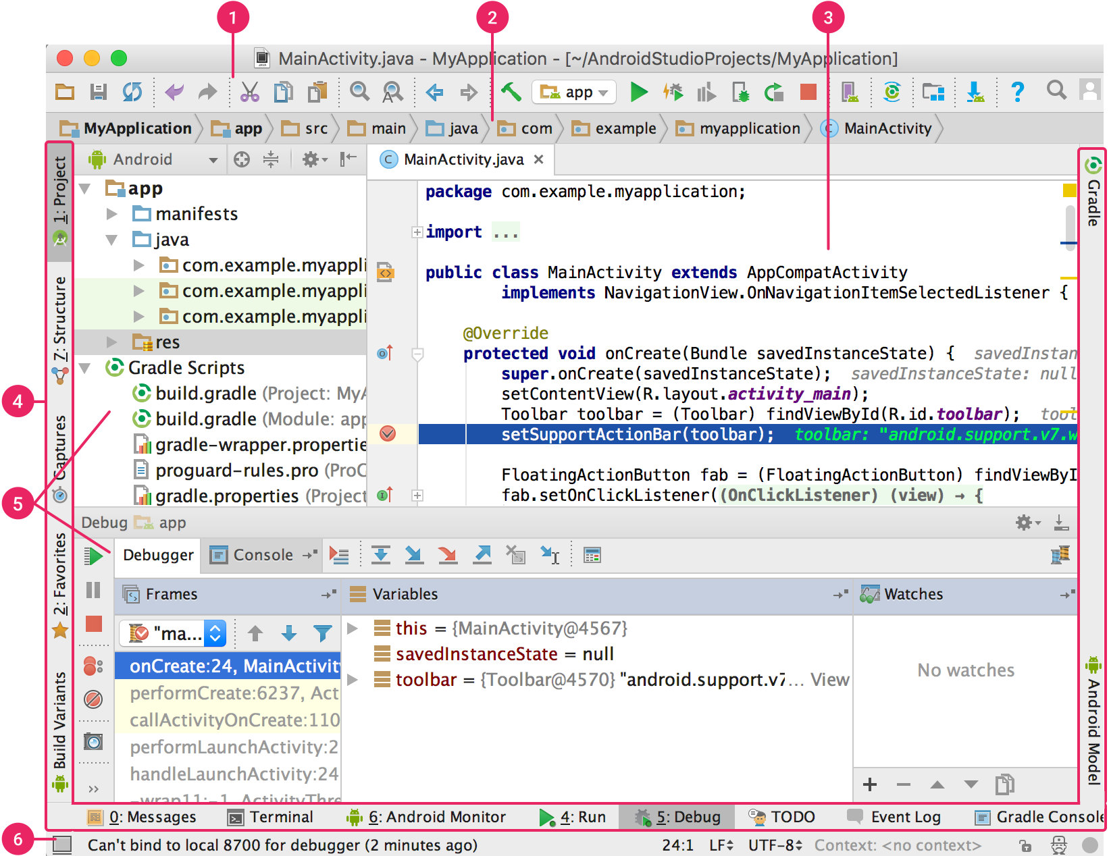

**Figure :** The Android Studio main window.

1. The toolbar lets you carry out a wide range of actions, including running your app and launching Android tools.
2. The navigation bar helps you navigate through your project and open files for editing. It provides a more compact view of the structure visible in the Project window.
3. The editor window is where you create and modify code. Depending on the current file type, the editor can change. For example, when viewing a layout file, the editor displays the Layout Editor.
4. The tool window bar runs around the outside of the IDE window and contains the buttons that allow you to expand or collapse individual tool windows.
5. The tool windows give you access to specific tasks like project management, search, version control, and more. You can expand them and collapse them.
6. The status bar displays the status of your project and the IDE itself, as well as any warnings or messages

4.Micro Controller:

4.1 What is Micro Controller?

A microcontroller is a small, low-cost computer-on-a-chip which usually includes :

– An 8 or 16 bit microprocessor (CPU).

– A small amount of RAM.

– Programmable ROM and/or flash memory.

– Parallel and/or serial I/O.

– Timers and signal generators.

– Analog to Digital (A/D) and/or Digital to Analog (D/A) conversion.

Often used to run dedicated code that controls one or more tasks in the operation of a device or a system.

Also called embedded controllers, because the microcontroller and support circuits are often built into, or embedded in, the devices they control.

Devices that utilize microcontrollers include car engines, consumer electronics (VCRs, microwaves, cameras, pagers, cell phones , etc,. ), computer peripherals (keyboards, printers, modems,etc,. ), test/measurement equipment (signal generators, multimeters, oscilloscopes,etc,.).

Microcontrollers usually must have low-power requirements (~. 05 - 1 W as opposed to ~10 - 50 W for general purpose desktop CPUs) since many devices they control are battery-operated.

4.2 How are Micro Controller Classified?

The microcontroller are characterized regarding buswidth, instruction set and memory structure.

1.According to Number of Bits:

8-bits: In 8-bit microcontroller, the point when the internal bus is 8-bit then the ALU is performs the arithmetic and logic operations. The examples of 8-bit microcontrollers are Intel 8031/8051, PIC1x and Motorola MC68HC11 families.

16-bits: he 16-bit microcontroller performs greater precision and performance as compared to 8-bit. For example 8 bit microcontrollers can only use 8 bits, resulting in a final range of 0×00 – 0xFF (0-255) for every cycle. In contrast, 16 bit microcontrollers with its 16 bit data width has a range of 0×0000 – 0xFFFF (0-65535) for every cycle. A longer timer most extreme worth can likely prove to be useful in certain applications and circuits. It can automatically operate on two 16 bit numbers. Some examples of 16-bit microcontroller are 16-bit MCUs are extended 8051XA, PIC2x, Intel 8096 and Motorola MC68HC12 families.

32-bits: The 32-bit microcontroller uses the 32-bit instructions to perform the arithmetic and logic operations. These are used in automatically controlled devices including implantable medical devices, engine control systems, office machines, appliances and other types of embedded systems. Some examples are Intel/Atmel 251 family, PIC3x.

2.According to Memory Devices::

Embedded memory microcontroller: When an embedded system has a microcontroller unit that has all the functional blocks available on a chip is called an embedded microcontroller. For example, 8051 having program & data memory, I/O ports, serial communication, counters and timers and interrupts on the chip is an embedded microcontroller.

External memory microcontroller: : When an embedded system has a microcontroller unit that has not all the functional blocks available on a chip is called an external memory microcontroller. For example, 8031 has no program memory on the chip is an external memory microcontroller.

3.According to Instruction Set:

CISC:  CISC is a Complex Instruction Set Computer. It allows the programmer to use one instruction in place of many simpler instructions.

RISC: The RISC is stands for Reduced Instruction set Computer, this type of instruction sets reduces the design of microprocessor for industry standards. It allows each instruction to operate on any register or use any addressing mode and simultaneous access of program and data.

4.According to Memory Architecture:

Harvard memory architecture: The point when a microcontroller unit has a dissimilar memory address space for the program and data memory, the microcontroller has Harvard memory architecture in the processor.

Princeton memory architecture: The point when a microcontroller has a common memory address for the program memory and data memory, the microcontroller has Princeton memory architecture in the processor.

4.3 Application Of Micro Controller

Mobile phones

Auto mobiles

Washing Machines

Cameras

Security Alarms

4.4 Type of Micro Controller

1.Microcontroller 8051:

It is a 40pin microcontroller with Vcc of 5V connected to pin 40 and Vss at pin 20 which is kept 0V. And there are input and output ports from P1.0 – P1.7 and which having open drain feature. Port3 has got extra features. Pin36 has open drain condition and pin17 has internally pulled up transistor inside the microcontroller. When we apply logic 1 at port1 then we get logic 1 at port21 and vice versa. The programming of microcontroller is dead complicate. Basically we write a program in C-language which is next converted to machine language understand by the microcontroller. A RESET pin is connected to pin9, connected with a capacitor. When the switch is ON, the capacitor starts charging and RST is high. Applying a high to the reset pin resets the microcontroller. If we apply logic zero to this pin, the program starts execution from the beginning.

2.Renesas Microcontroller:

Renesas is latest automotive microcontroller family that offers high performance feature with exceptionally low power consumption over a wide and versatile extend of items. This microcontroller offers rich functional security and embedded safety characteristics required for new and advanced automotive applications. The core structure of microcontroller CPU support high reliability and high performance requirements.

The Renesas microcontroller offering low power, high performance, modest packages and the largest range of memory sizes combined together with characteristics rich peripherals.

3.AVR MicroController:

AVR microcontroller is developed by Alf-Egil Bogen and Vegard Wollan from Atmel Corporation. The AVR microcontrollers are modified Harvard RISC architecture with separate memories for data and program and speed of AVR is high when compare to 8051 and PIC. The AVR is stands for Alf-Egil Bogen and Vegard Wollan’s RISC processor.

### 4.PIC Microcontroller:

### PIC is a peripheral interface controller, developed by general instrument’s microelectronics, in the year of 1993. It is controlled by the software. They could be programmed to complete many task and control a generation line and many more. PIC microcontrollers are finding their way into new applications like smart phones, audio accessories, video gaming peripherals and advanced medical devices.

5.USB Cable

5.1 What is USB Cable?

USB stands for Universal Serial Bus.

It is invented and standardized by a group of computer and peripherals manufactures in 1995 and itt was compete with IEEE1394.

5.2 Why we use USB Cable?

Connection of the PC to the telephone in order to transmit data from device to another

Ease-of-use

Support plug and play

Can add lots of device to a **XX**

The logical topology of the USB is a star structure

It is similar to computer network

The USB uses a polling protocol up to 7 level

Combines low speed and high speed bus activity

USB enables shared access for both speed

Automatic configuring of devices and a serial bus which is simplified and easy to plug into

Attach / detach easily without restarting system

6.Sensors

6.1 What is Sensor?

American National Standards Institute – A device which provides a usable output in response to a specified measurand

A sensor acquires a physical quantity and converts it into a signal suitable for processing (e.g. optical, electrical, mechanical)

Nowadays common sensors convert measurement of physical phenomena into an electrical signal

Active element of a sensor is called a transducer(Microphone, Loud Speaker, Biological Senses (e.g. touch, sight)

6.2 Commonly Detectable Phenomena

Biological

Chemical

Electric

Electromagnetic

Heat/Temperature

Magnetic

Mechanical motion (displacement, velocity, acceleration, etc.)

Optical

Radioactivity

6.3 Need for Sensors

Sensors are pervasive. They are embedded in our bodies, automobiles, airplanes, cellular telephones, radios, chemical plants, industrial plants and countless other applications.

Without the use of sensors, there would be no automation !! – Imagine having to manually fill Poland Spring bottles

6.4 Types of Sensor

**1.Temperature Sensor:**

This device collects information about temperature from a source and converts into a form that is understandable by other device or person. The best illustration of a temperature sensor is mercury in glass thermometer. The mercury in the glass expands and contracts depending on the alterations in temperature. The outside temperature is the source element for the temperature measurement. The position of the mercury is observed by the viewer to measure the temperature. There are two basic types of temperature sensors:

Contact Sensors – This type of sensor requires direct physical contact with the object or media that is being sensed. They supervise the temperature of solids, liquids and gases over a wide range of temperatures.

    Non contact Sensors – This type of sensor does not require any physical contact with the object or media that is being sensed. They supervise non-reflective solids and liquids but are not useful for gases due to natural transparency. These sensors use Plank’s Law to measure temperature. This law deals with the heat radiated from the source of heat to measure the temperature.

**Working of different types of Temperature Sensors along with examples:**

**(i).Thermocouple**

They are made of two wires (each of different homogeneous alloy or metal) which form a measuring junction by joining at one end. This measuring junction is open to the elements being measured. The other end of the wire is terminated to a measuring device where a reference junction is formed. The current flows through the circuit since the temperature of the two junctions are different. The resulted milli-voltage is measured to determine the temperature at the junction. The diagram of thermocouple is shown below.

**(ii)     Resistance Temperature Detectors (RTD)**

These are types of thermal resistors that are fabricated to alter the electrical resistance with the alteration in temperature. They are very expensive than any other temperature detection devices. The diagram of Resistance Temperature Detectors is shown below.

**(iii) Thermistors**

They are another kind of thermal resistor where a large change in resistance is proportional to small change in temperature.

**2.IR Sensor**

This device emits and/or detects infrared radiation to sense a particular phase in the environment. Generally, thermal radiation is emitted by all the objects in the infrared spectrum. The [infrared sensor](http://www.engineersgarage.com/electronic-circuit/infrared-ir-sensor) detects this type of radiation which is not visible to human eye.

**Advantages**

·        Easy for interfacing

·        Readily available in market

**Disadvantages**

·        Disturbed by noises in the surrounding such as radiations, ambient light etc.

**Working**

The basic idea is to make use of IR LEDs to send the infrared waves to the object. Another IR diode of the same type is to be used to detect the reflected wave from the object. The diagram is shown below.

**Applications**

·        Thermography – According to the black body radiation law, it is possible to view the environment with or without visible illumination using thermography

·        Heating – Infrared can be used to cook and heat food items. They can take away ice from the wings of an aircraft. They are popular in industrial field such as, print dying, forming plastics, and plastic welding.

·       Spectroscopy – This technique is used to identify the molecules by analysing the constituent bonds. This technique uses light radiation to study organic compounds.

·        Meteorology – Cloud heights, calculate land and surface temperature is possible when weather satellites are equipped with scanning radiometers.

·        Photobiomodulation – This is used for chemotherapy in cancer patients. This is used to treat anti herpes virus.

·        Climatology – Monitoring the energy exchange between the atmosphere and earth.

·       Communications – Infra red laser provide light for optical fibre communication. These radiations are also used for short range communications among mobiles and computer peripherals.

3. **UV Sensor**

These sensors measure the intensity or power of the incident ultraviolet radiation. This form of electromagnetic radiation has wavelengths longer than x-rays but is still shorter than visible radiation. An active material known as polycrystalline diamond is being used for reliable ultraviolet sensing. UV sensors can discover the exposure of environment to ultraviolet radiation.

**Criteria to select a UV Sensor**

·        Wavelength ranges in nanometres (nm) that can be detected by the UV sensors.

·        Operating temperature

·        Accuracy

·        Weight

·        Power range

**Working**

The UV sensor accepts one type of energy signal and transmits different type of energy signals.

To observe and record these output signals they are directed to an electrical meter. To create graphs and reports, the output signals are transmitted to an analog-to-digital converter (ADC), and then to a computer with software.

**Examples include:**

·        UV phototubes are radiation-sensitive sensors supervise UV air treatments, UV water treatments, and solar irradiance.

·        Light sensors measure the intensity of incident light.

·        UV spectrum sensors are charged coupled devices (CCD) utilized in scientific photography.

·        Ultraviolet light detectors.

·        Germicidal UV detectors.

·        Photo stability sensors.

**Applications**

·        Measures the portion of the UV spectrum which sunburns human skin

·        Pharmacy

·        Automobiles

·        Robotics

·        Printing industry for solvent handling and dyeing processes

·        Chemical industry for the production, storage, and transportation of chemicals

**4.  Touch Sensor**

A touch sensor acts as a variable resistor as per the location where it is touched. The figure is as shown below.

A touch sensor is made of:

·        Fully conductive substance such as copper

·        Insulated spacing material such as foam or plastic

·        Partially conductive material

**Principle and Working**

The partially conductive material opposes the flow of current. The main principle of the linear position sensor is that the current flow is more opposed when the length of this material that must be travelled by the current is more. As a result, the resistance of the material is varied by changing the position at which it makes contact with the fully conductive material.

Generally, softwares are interfaced to the touch sensors. In such a case, a memory is being offered by the software. They can memorize the ‘last touched position’ when the sensor is deactivated. They can memorize the ‘first touched position’ once the sensor gets activated and understand all the values related to it. This act is similar to how one moves the mouse and locates it at the other end of mouse pad in order to move the cursor to the far side of the screen.

**Applications**

The touch sensors being cost effective and durable are used in many applications such as

·        Commercial – Medical, vending, Fitness and gaming

·        Appliances – Oven, Washing machine/dryers, dishwashers, refrigerators

·        Transportation – Cockpit fabrication and streamlining control among the vehicle manufacturers

·        Fluid level sensors

·        Industrial Automation – Position and liquid level sensing, human touch control in automation applications

·        Consumer Electronics – Provides a new feel and level of control in various consumer products

**5. Proximity Sensor**

A proximity sensor detects the presence of objects that are nearly placed without any point of contact. Since there is no contact between the sensors and sensed object and lack of mechanical parts, these sensors have long functional life and high reliability.  The different types of proximity sensors are Inductive Proximity sensors, Capacitive Proximity sensors, Ultrasonic proximity sensors, photoelectric sensors, Hall-effect sensors, etc.

**Working**

A proximity sensor emits an electromagnetic or electrostatic field or a beam of electromagnetic radiation (such as infrared), and waits for the return signal or changes in the field. The object which is being sensed is known as the proximity sensor's target.

Inductive Proximity sensors – They have an oscillator as input to change the loss resistance by the proximity of an electrically conductive medium. These sensors are preferred for metal targets.

Capacitive Proximity sensors – They convert the electrostatic capacitance variation flanked by the detecting electrode and the ground electrode. This occurs by approaching the nearby object with a variation in an oscillation frequency. To detect the nearby object, the oscillation frequency is transformed into a direct current voltage which is compared with a predetermined threshold value. These sensors are preferred for plastic targets.

**Applications**

·        Used in automation engineering to define operating states in process engineering plants, production systems and automating plants

·        Used in windows, and the alarm is activated when the window opens

·        Used in machine vibration monitoring to calculate the difference in distance between a shaft and its support bearing

**Applications**

**Sensors are used in many kinds of applications such as:**

·        Shock Detection

·        Machine monitoring applications

·        Vehicle dynamics

·        Low power applications

·        Structural Dynamics

·        Medical Aerospace

·        Nuclear Instrumentation

·        As pressure sensor in Mobiles ‘touch key pad’

·        Lamps which brighten or dim on touching its base

·        Touch sensitive buttons in elevators

## **Advanced Sensor Technology**

Sensor technology is used in wide range in the field of Manufacturing. The advanced technologies are as follows:

**1.     Bar-code Identification -** The products sold in the markets has a Universal Product Code (UPC) which is a 12 digit code. Five of the numbers signify the manufacturer and other five signify the product. The first six digits are represented by code as light and dark bars. The first digit signifies the type of number system and the second digit which is parity signifies the accuracy of the reading. The remaining six digits are represented by code as dark and light bars reversing the order of the first six digits.

The bar code reader can manage different bar code standards even without having the knowledge of the standard code. The disadvantage with bar coding is that the bar scanner is unable to read if the bar code is concealed with grease or dirt.

**2.     Transponders** - In the automobile section, Radio frequency device is used in many cases. The transponders are hidden inside the plastic head of the key which is not visible to anyone. The key is inserted in the ignition lock cylinder. As you turn the key, the computer transmits a radio signal to the transponder. The computer will not let the engine to ignite until the transponder responds to the signal. These transponders are energized by the radio signals.

**3.     Electromagnetic Identification of Manufactured Components** - This is similar to the bar code technology where the data can be coded on magnetic stripe. With magnetic striping, the data can be read even if the code is concealed with grease or dirt.

**4.     Surface Acoustic Waves -** This process is similar to the RF identification. Here, the part identification gets triggered by the radar type signals and is transmitted over long distances as compared to the RF systems.

**5.     Optical Character Recognition -** This is a type of automatic identification technique which uses alphanumeric characters as the source of information. In United States, Optical character recognition is used in mail processing centres. They are also used in vision systems and voice recognition systems.

7.How Application Works

Step 1:

Create a Android File

Step 2:

Install in Smart Phone

Step 3:

Connect USB Cable

Step 4:

Connect Ardinuo to USB Cable

Step 5:

Connect Sensor to Ardinuo

Step 6:

Launch Apllication

**Android Application code:**

**MainActivity.java**

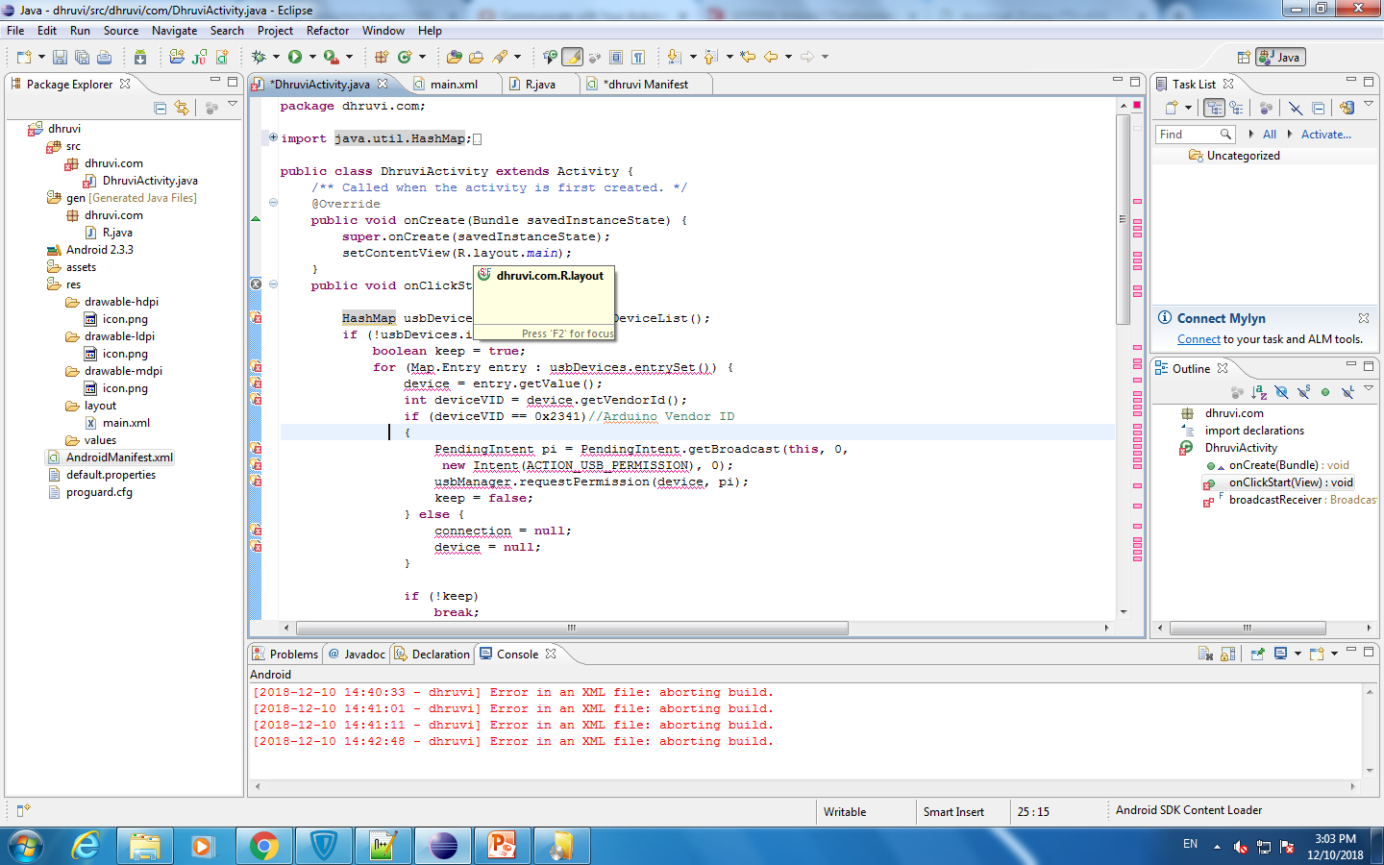

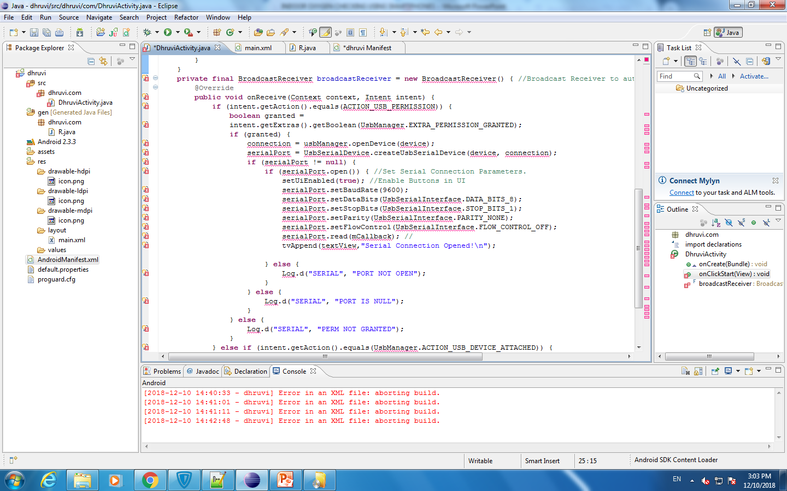

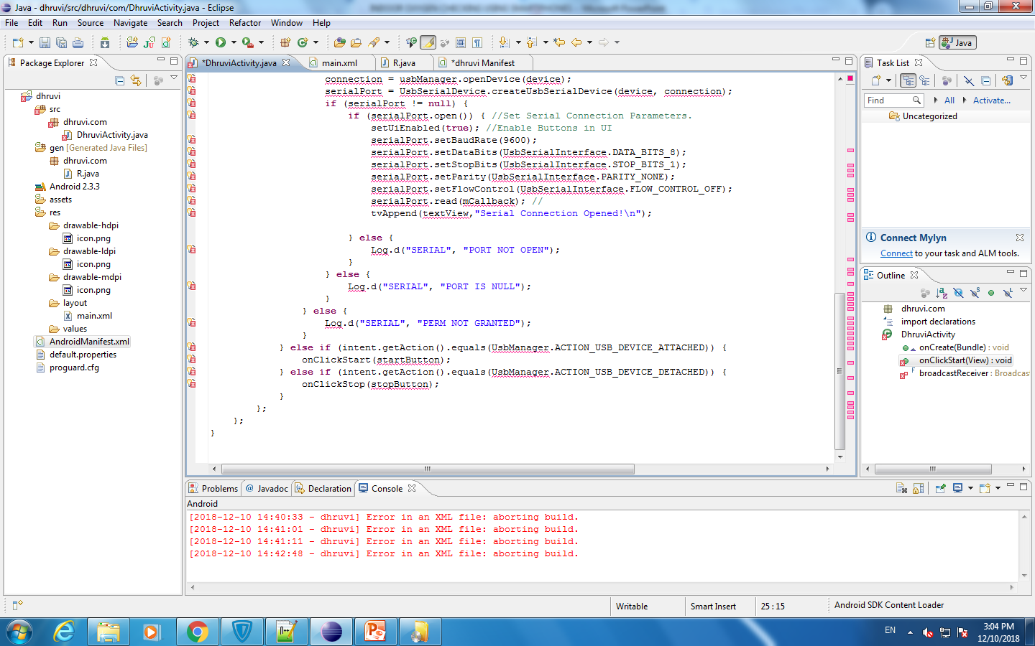

**dhruviActivity.xml**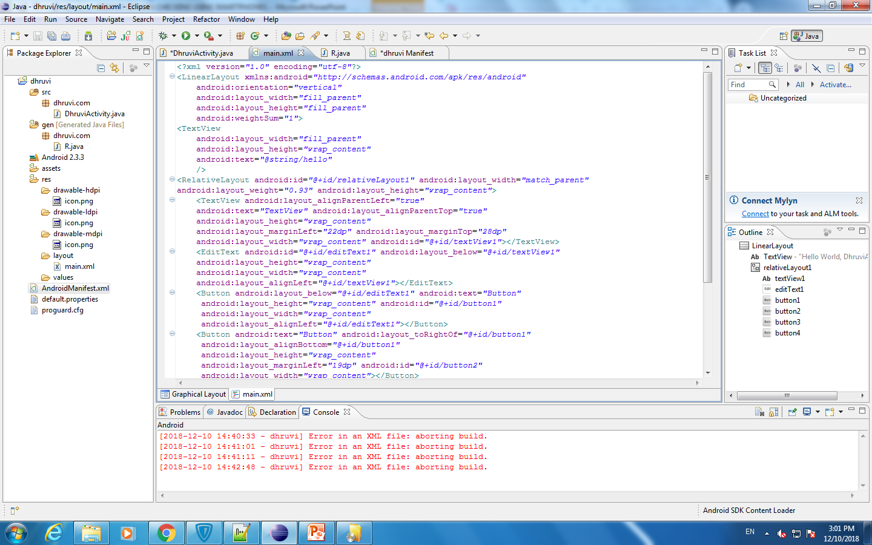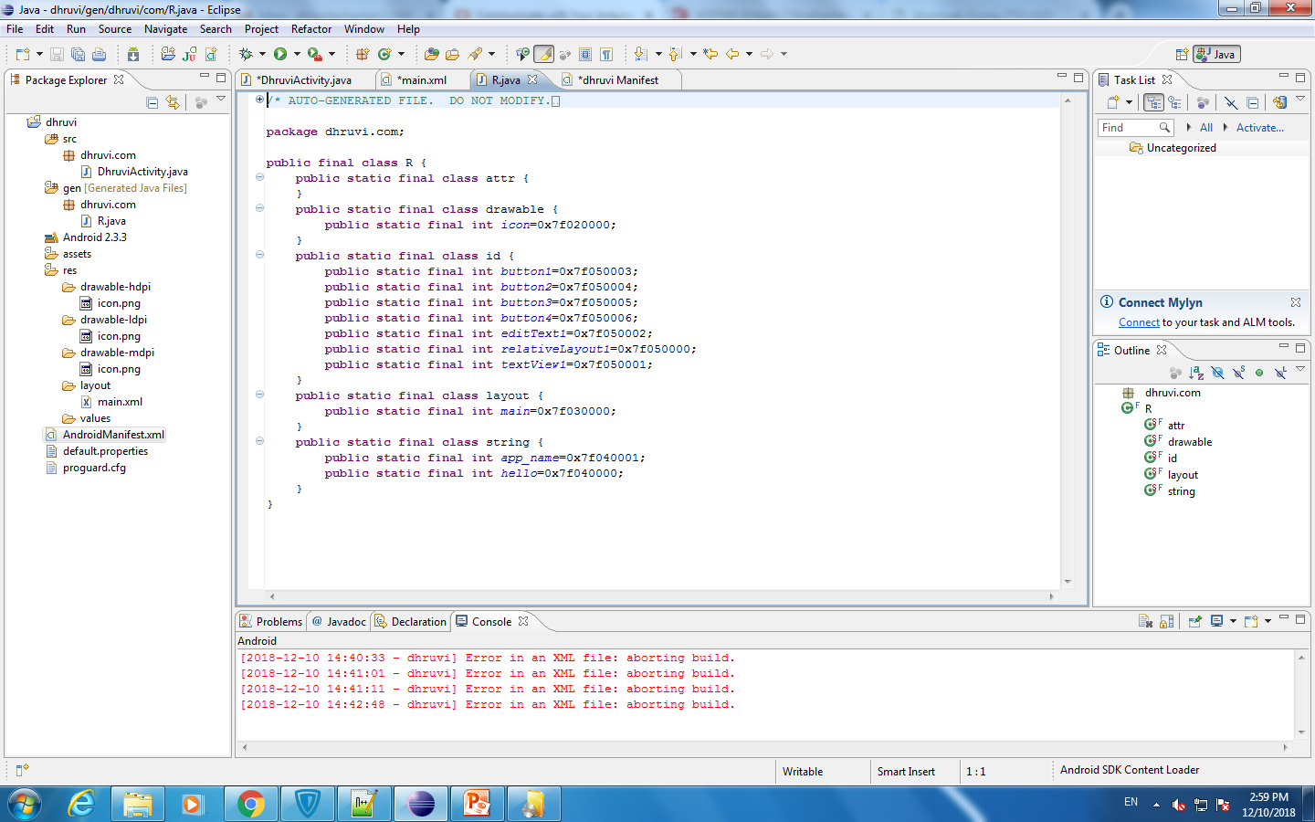

**AndroidManifest.xml**

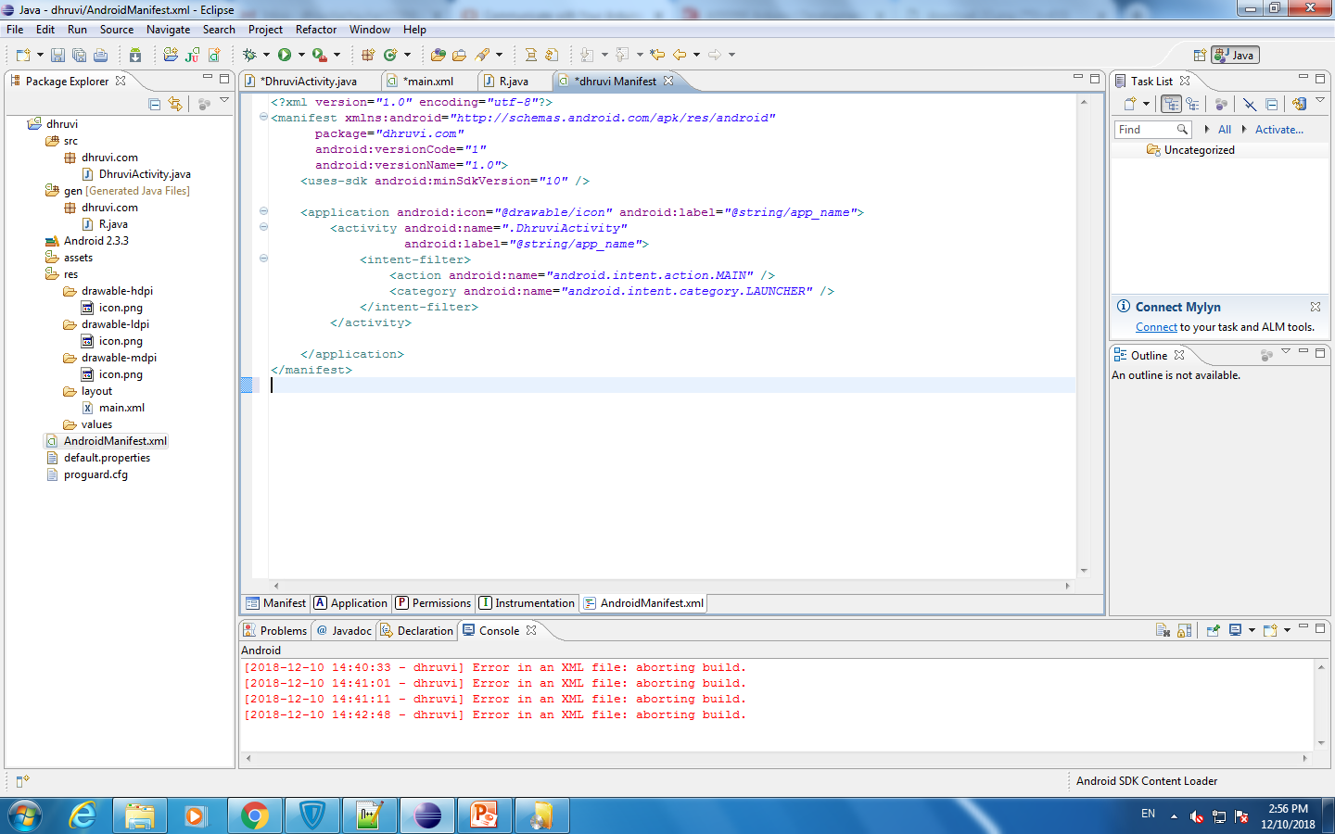

Conclusion

References